Automatic System For Determination of Blood Types Using Image Processing Techniques

**Bharat Institute of Engineering and Technology**

**@BIET**

Abstract-Determine blood type is essential before administering a blood transfusion, including in emergency situation. Currently, these tests are performed manually by technicians, which can lead to human errors. Various systems have been developed to automate these tests, but none is able to perform the analysis in time for emergency situations. This work aims to develop an automatic system to perform these tests in a short period of time, adapting to emergency situations. To do so, it uses the slide test and image processing techniques using the IMAQ Vision from National Instruments. The image captured after the slide test is processed and detects the occurrence of agglutination. Next the classification algorithm determines the blood type in analysis. Finally, all the information is stored in a database. Thus, the system allows determining the blood type in an emergency, eliminating transfusions based on the principle of universal donor and reducing transfusion reactions risks.

Terms-blood types; emergency situations; slide test;



Vision;

causes of fatal blood transfusions is extremely important to automate the procedure of these tests, the reading and interpretation of the results

In this sense, several systems have been developed TechniconAutoAnalyzer TechniconAutoAnalyzer II [15-16], Groupamatic [13, 17], Auto-Grouper [13] Olympus PK 7200 Immucor Galileo [22-25],Ortho 

® Innova System [26], Tango ® Automated Blood Bank [27] and Techno TwinStation [28]. But until now, no system delivers results available in time for it to be used in emergency situations [26].  this paper presents a novel system which automatically performs the determination of blood type, eliminating human error in a short interval of time for it to be used in emergency situations.

Thissystem is based on slide test for determining blood types and the software developed using image processing

image techniques;

I.

View;

techniques. The slide test consist of the mixture of one drop of blood and one drop of each reagent, anti-A, anti-B, anti-AB and anti-D, being the result interpreted according to the

 or not of The agglutination reaction

Before performing a blood transfusion is necessary to perform certain tests that are properly standardized. One of these tests is the determination of blood type and this test is essential for the realization of a safe blood transfusion,so as to administer a blood type that is compatible with the type of receiver However, there are certain emergency situations which due the risk of patient's life,it is necessary to administer blood immediately. In these cases, as the tests currently available require moving the laboratory,it may not be time to determine the blood type and is administered blood type negative considered universal donor and therefore provides less risk of incompatibility  However, despite the risk of incompatibilities be less sometimes occur transfusion reactions that cause death of the patient and it is essential to avoid them, administering blood based on the principle of donor only in emergencies  the ideal would be to determine the blood type of the patient even in emergency and administering compatible blood type from the first unit of blood transfusion. Secondly, the pre-transfusion tests are performed manuallyby technician's analysts, which sometimes lead to the occurrence of human errors in procedures, reading and interpreting of results. Since these human errors can translate into fatal consequences for the patient,being one of the most significant

0

means that occurred reaction between the antibody and the antigen,indicating the presence of the antigen appropriate. The combination of the occurrence of  or non occurrence,determines the blood type of the patient [29]. Thus, the software developed based in image processing techniques allows, through an image captured after the procedure of the slide test detect the  of and consequently the blood type of the patient.

1. IMAGE PROCESSING TECHNIQUES

The  of slide test is captured by a CCD camera (Sony Cyber-shot DSC-S750) consisting of a color image composed of four samples of blood and reagent. Thisimage will be processed by image processing techniques developed with the IMAQ Vision software from National Instruments [30]. The image processing techniques developed are presented in this section. The descriptions of all the functions presented are presented in the references mentioned [30-32].

I. Image Buffer: Add Copy(l) [30-32], Figure I.

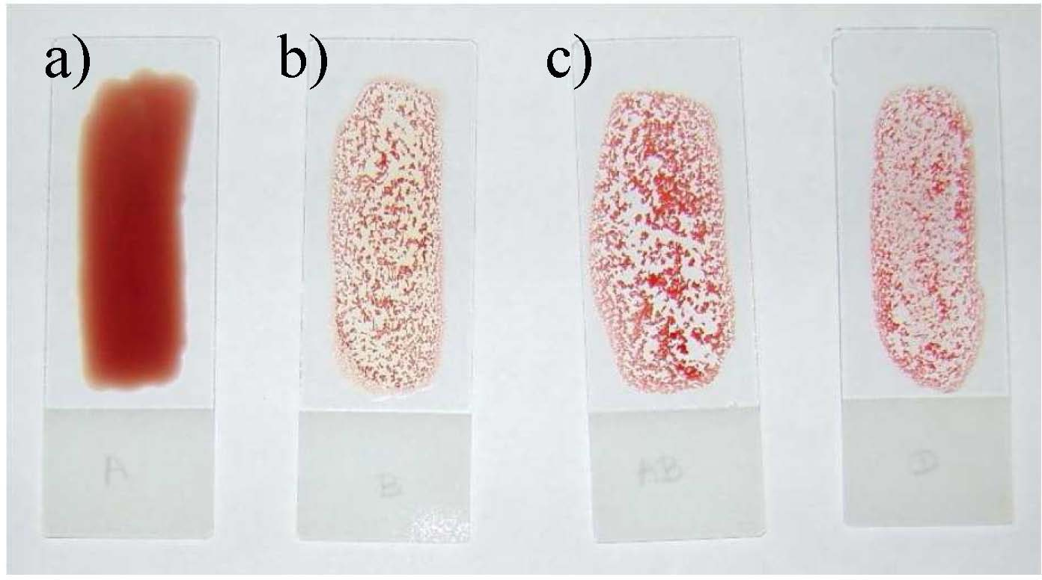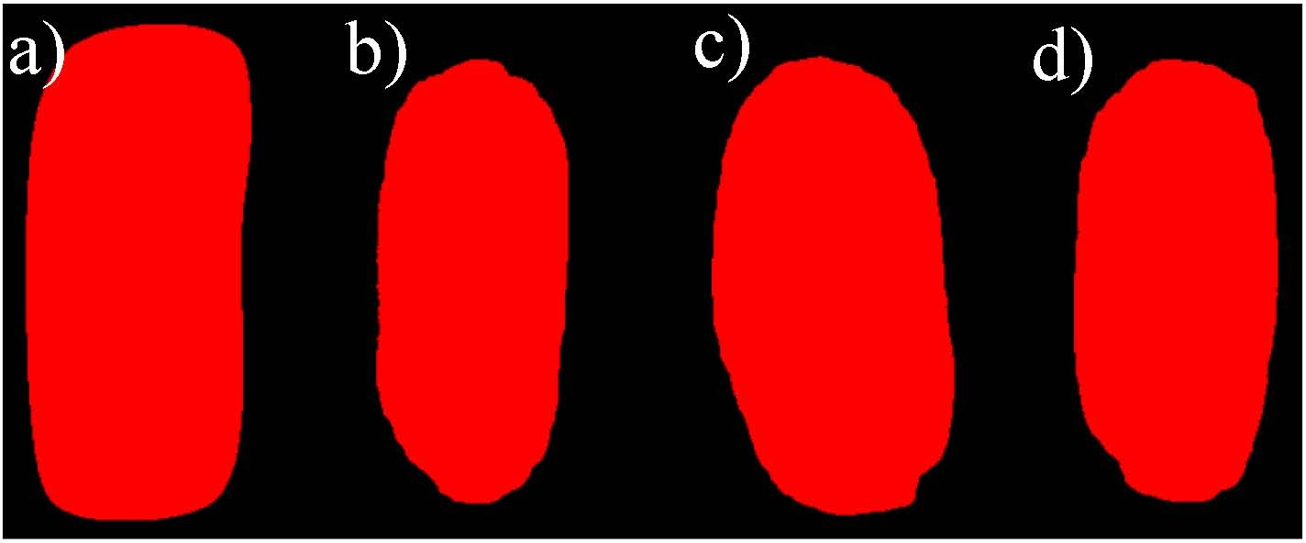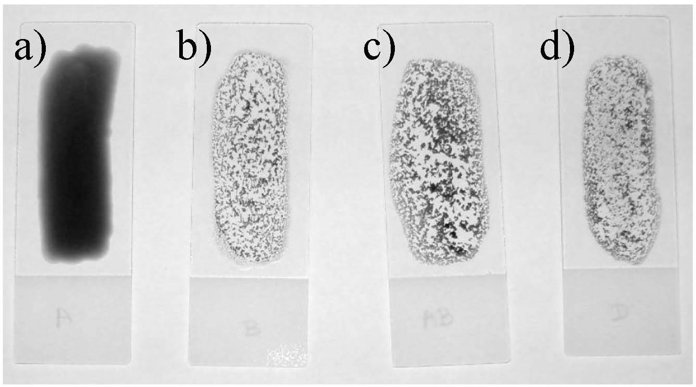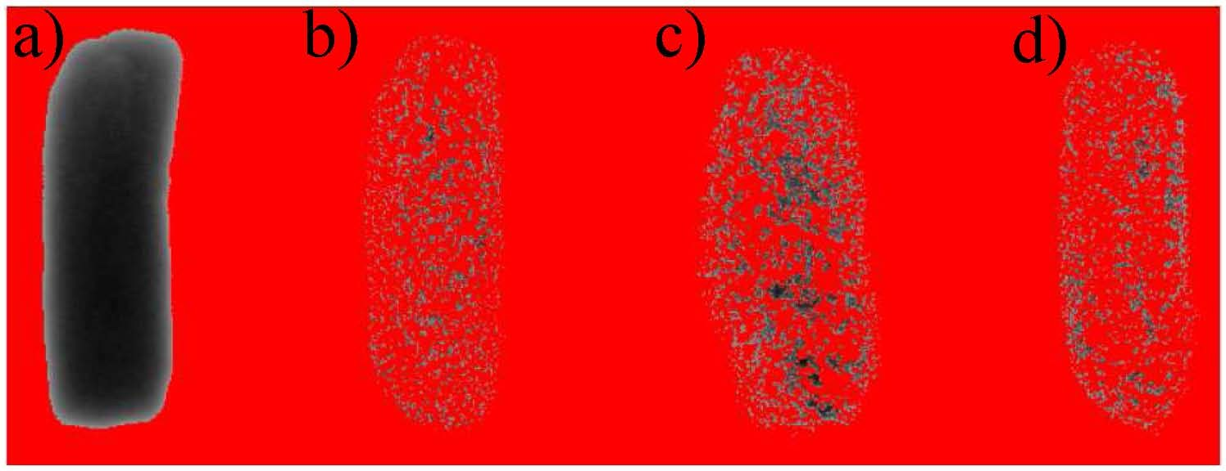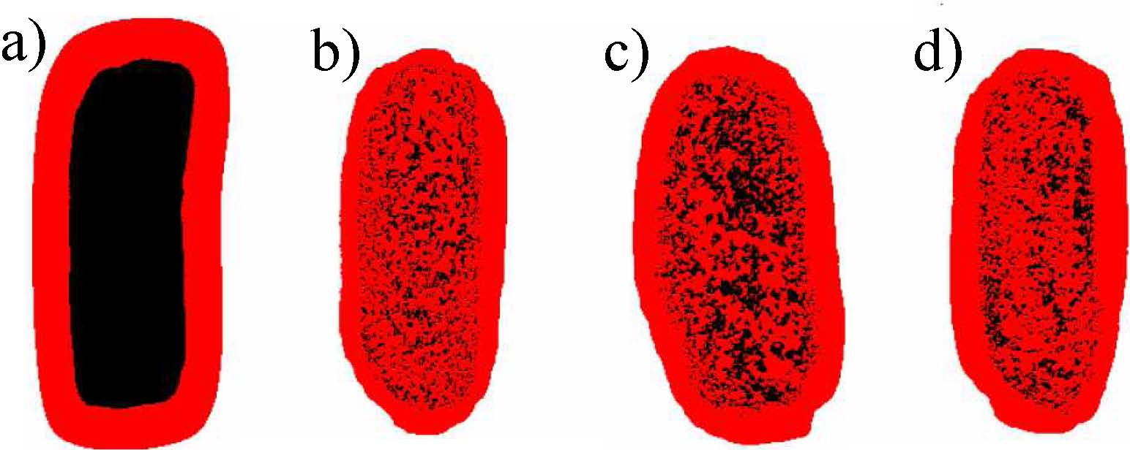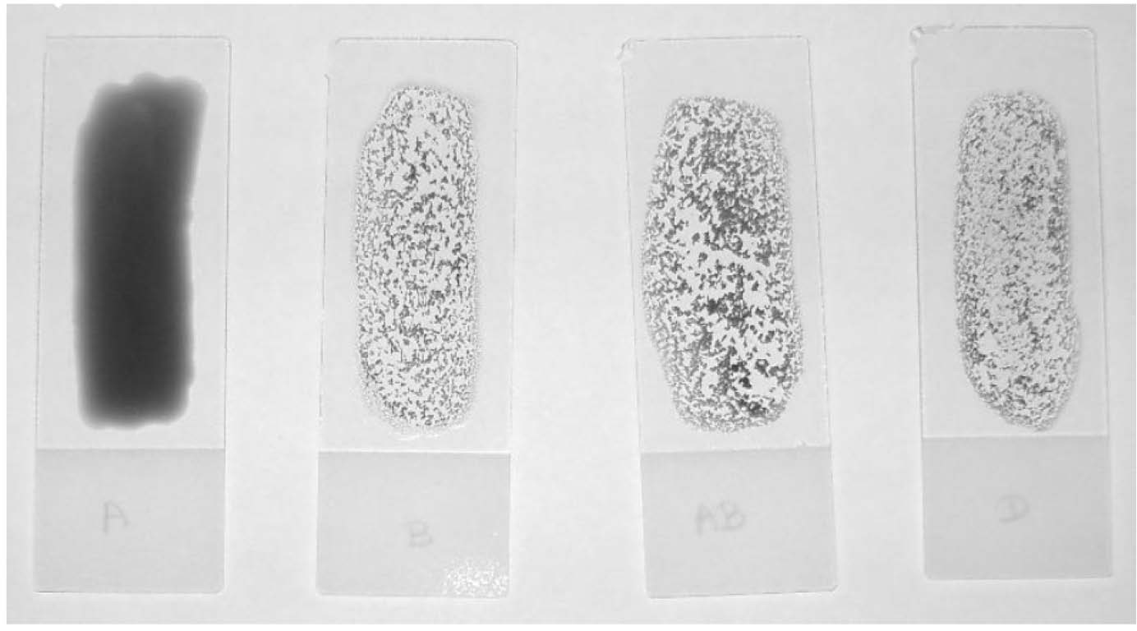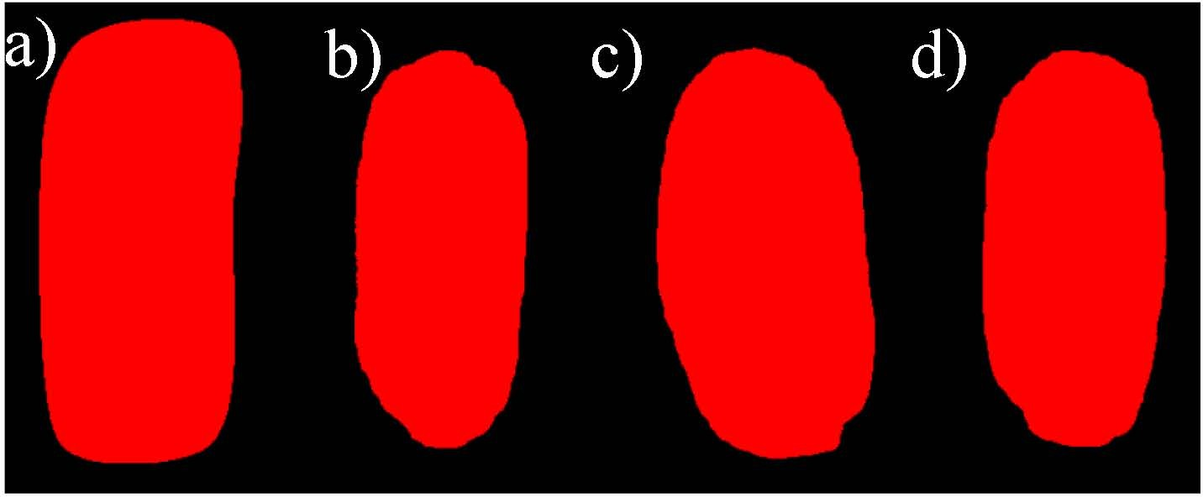

d)

Figure 1. Original Image captured by the CCD camera (a) Reagent anti-A (b) Reagent anti-B (c) Reagent anti-AB (d) Reagent anti-D.

1. Color Plane Extraction: RGB Green Plane [30-32], Figure 2.

Figure 2. Image obtained by applying Color Plane Extraction: RGB Green Plane function in the original image of Figure 1.

1. Auto Threshold: Clustering [30-32], Figure 3.

Figure 3. Image obtained by applying the Auto Threshold: Clustering in image of Figure 2.

1. Local Threshold: Niblack [30-32], Figure 4.

Figure 4. Image obtained by applying the Local Threshold: Niblack function under the image of Figure 3.

1. Advanced Morphology: Fill holes [30-32], Figure 5.

Figure 5. Image obtained by the application of Advanced Function Morphology: Fill holes function in the image of Figure 4.

1. Advanced Morphology: Remove small objects [30-32], Figure 6.

Figure 6. Image obtained by applying the Advanced Morphology: Remove small objects function in the image of Figure 5.

The techniques presented are used to automate the process of determining blood type. Together with another function later, ensure that the analysis is carried out automatically, but needs to ensure that the function of particle analysis has only four particles corresponding to mixed blood and reagent.

1. Particle Analysis [30-32], TABLE 1.

TABLE 1. RESULTS OF ApPLICATION OF PARTICLES ANAYLlS1S FUNCTION ON IMAGE OF FIGURE 6

|  |  |  |
| --- | --- | --- |
| Particle | Center of Mass X | Center of Mass Y |
|  | 338,48 | 537,65 |
| 2 | 1163,82 | 557,58 |
| 3 | 735,68 | 545,93 |
| 4 | 1570,67 | 545,81 |

1. Image Buffer: Retrieve buffer # 1 [30-32], Figure 1.
2. Color Plane Extraction: HSL Luminance Plane [30- 32], Figure 7.
   1. b) c) d)

Figure 7. Image obtained by applying the Color Plane Extraction: HSL Luminance Plane function to the original image of Figure 6.

1. Set Coordinate System [30-32], Figure 8.

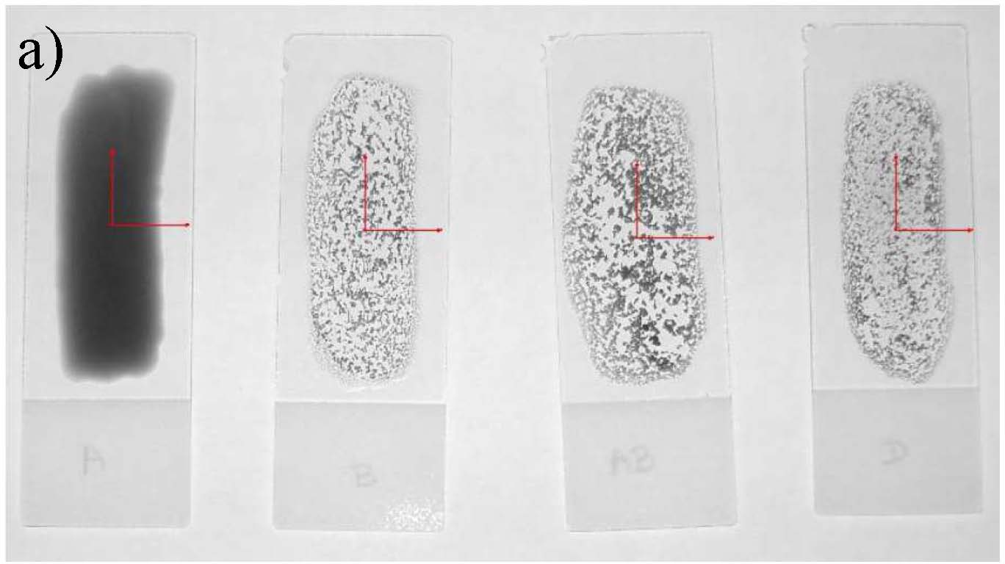

b)

c)

d)

Figure 8. Image resulting of the application of Set Coordinate System functions to each of the particles in the image.

1. Quantify [30-32], Figure 9 and TABLE 2.

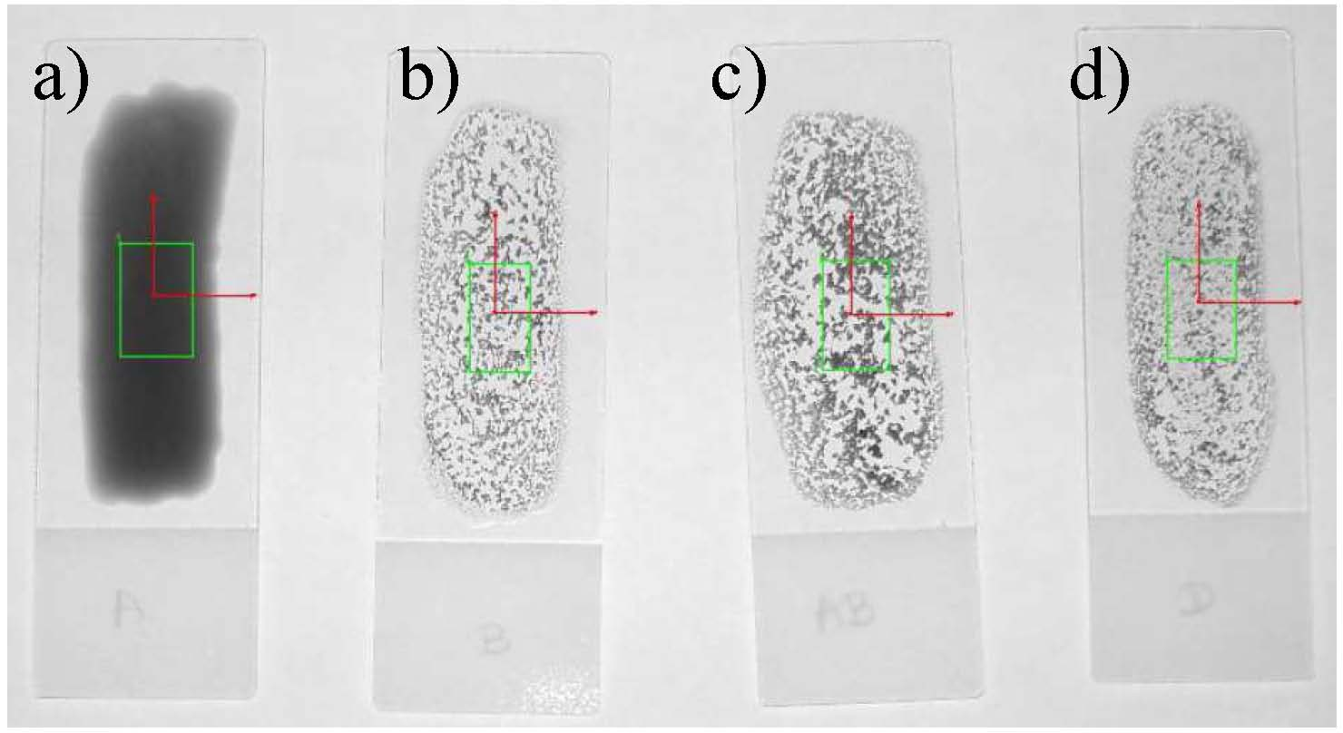

Figure 9.lmage resulting from application of the Quantify function.

TABLE 2. RESULTS OF ApPLICATION OF THE QUANTIFY FUNCTION TN FIGURE

9



Figure Area Mean Standard Minimal Maximal Value Deviation Value Value

1. DATABASE

To store the information resulting from the analysis of the agglutination detection perfonned through the image processing techniques and the result of the classification algorithm (blood type), a database was constructed. The built database can store images captured and used in image processing techniques (each image contain four samples of blood and reagent), the standard deviation calculated in each four samples of the image, the result based by the value of standard deviation obtained for each of the samples (if agglutinated or not agglutinated in the sample of blood and reagent) and the fmal result obtained by the classification algorithm (corresponding of blood type). The database was developed with the Microsoft Office Access 2007, since this was compatible with the software used to process the images, IMAQ Vision 2010 and the software used to develop the classification algorithm LabView, both from National Instruments.

1. SOFTWARE DEVELOPED

The developed software allows by an image captured by a CCD camera detecting the occurrence of agglutination, through image processing techniques developed for determine the occurrence of agglutination. Secondly allows determine the blood type of the patient through the classification algorithm developed. Finally, allows store the information in a database built. All the software was developed with LabView from National Instruments [31] and the front panel is shown in

|  |  |  |  |  |  |  |
| --- | --- | --- | --- | --- | --- | --- |
| 9(a) | 0,5 | 57,6 | 5,2 | 43,0 | 83,0 | Figure 10. |
| 9(b) | 0,4 | 193,5 | 43,7 | 63,0 | 250,0 | 'l'U,Usas\PitlKla\DisJa \A1l'lbr<entE-dE! Trabdtla-\kJoos.A.ewttados\ |
| 9(c) | 0,5 | 176,9 | 53,4 | 46,0 | 248,0 |  |
| 9(d) | 0,4 | 182,9 | 25,5 | 61,0 | 234,0 |  |



It is through this function that detects the occurrence of agglutination or non occurrence in each of the four blood samples and reagent, such being essential to value of the standard deviation. It was found that in samples where no agglutination occurs, the standard deviation values do not exceed 16, and in general samples with standard deviation values between 0 and 10. Moreover, samples where agglutination occurs present standard deviation values greater than or equal to 16, and in general samples with values of standard deviation between 20 and 70. No samples non agglutinated was found with values of standard deviation greater than 16 or equal to 16, or samples agglutinated with standard deviation values below 16. Thus, it was established as a threshold value for classification of standard deviation 16, in which samples with standard deviation value below 16 are classified as samples where no agglutination occurred and samples with standard deviation values greater than or equal to 16 are samples classified as agglutination occurred. Observing TABLE 2 and the Figure 9 shows that in the sample where no agglutination occurred, Figure 9 a) the standard deviation value is 5.2 and is therefore less than 16, and where the agglutination occur in Figure 9 b), c) and d), standard deviation value is 43.7, 53.4 and 25.5, respectively, and therefore greater than 16.

Figure 10. Developed Software. (a) Selection of the image (b) Selection od File Database.dsn and entering the name of the table of database (c) Original

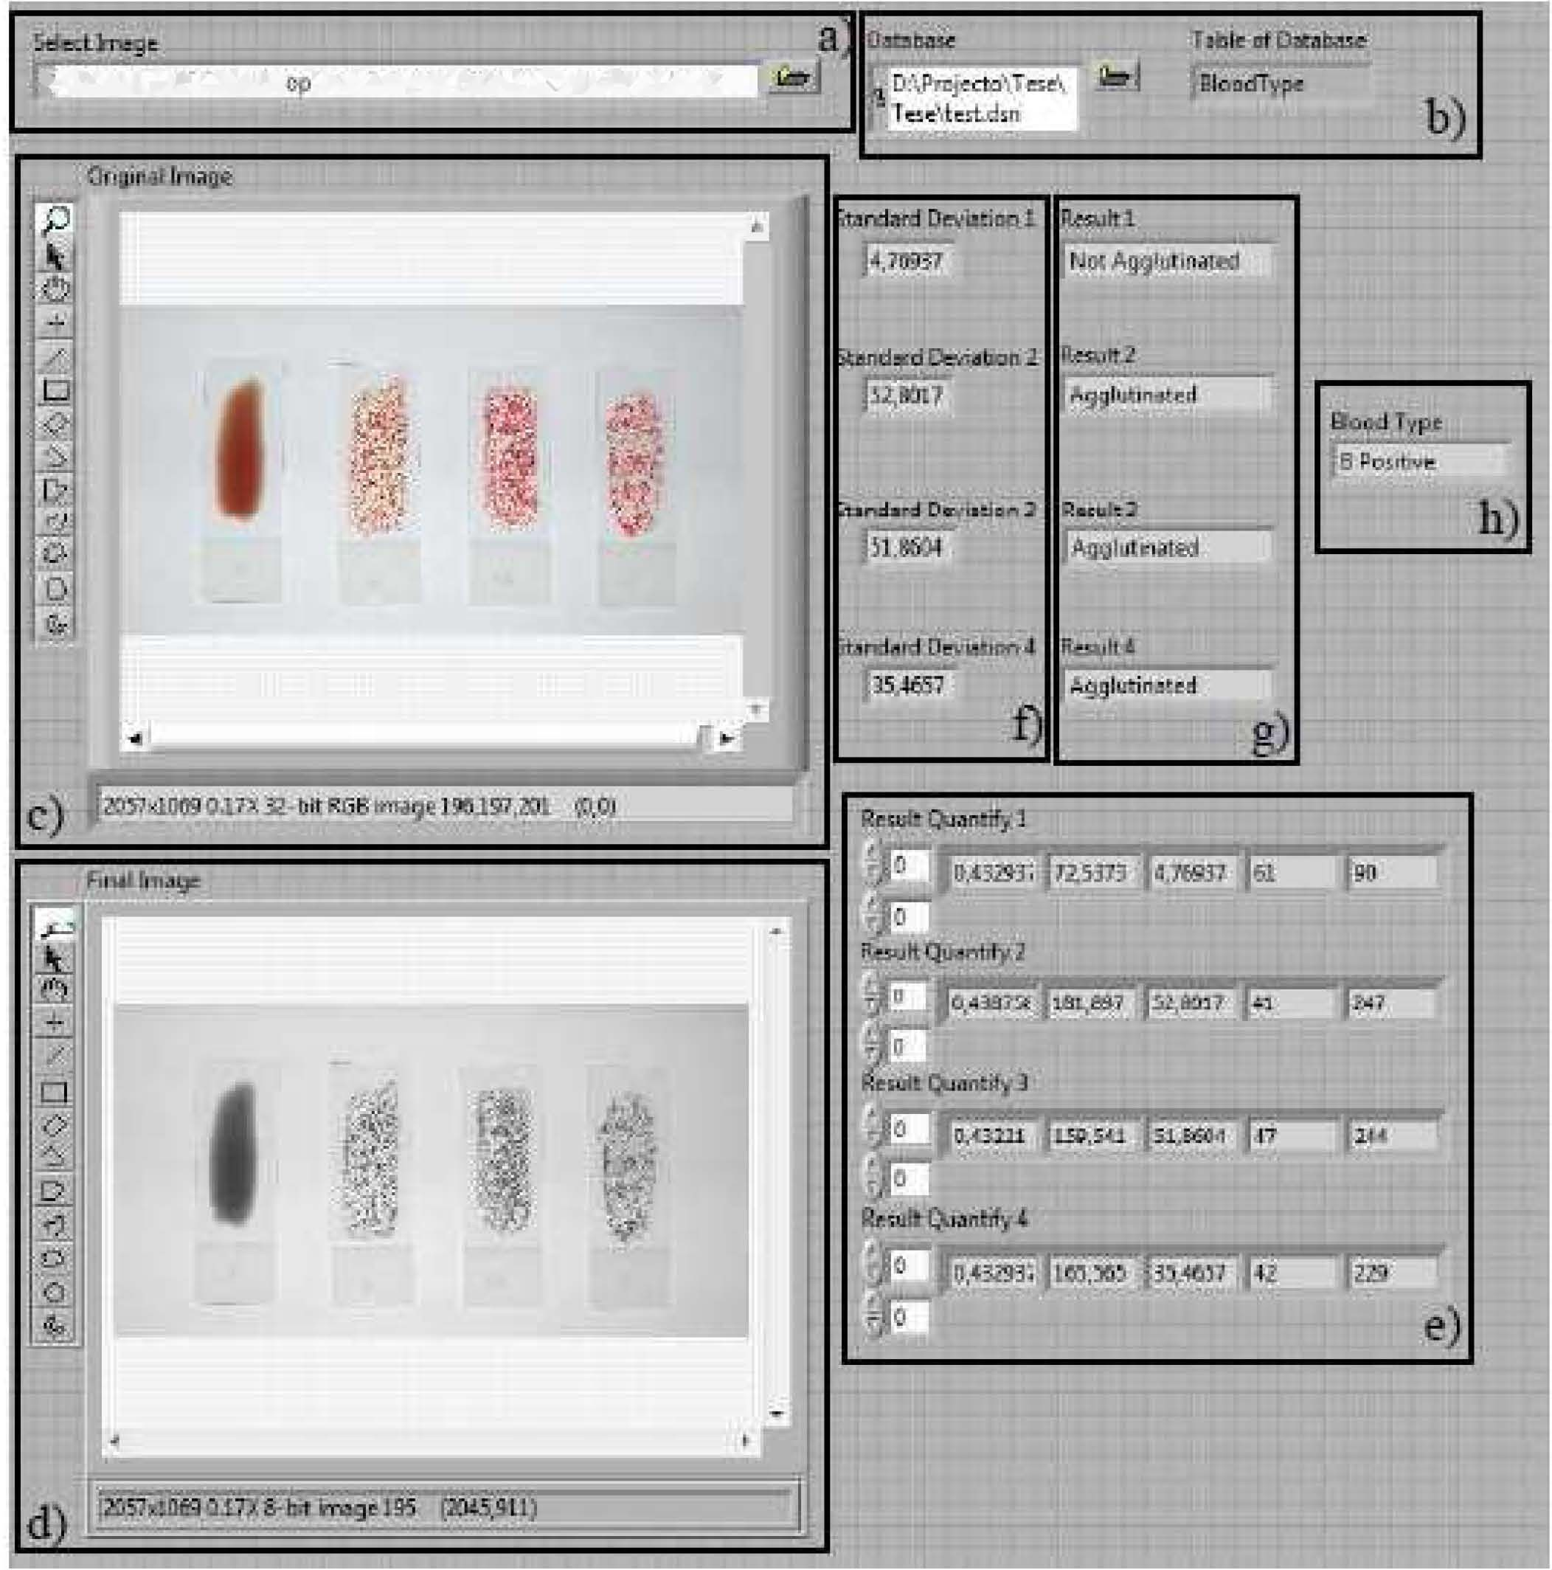

Image (d) Final image obtained with the image processing techniques (e) Results of the QuantifY function (1) Values of standard deviation of each sample (g) Results based on de standard deviation of each sample (h) Result

of the classification algorithm.

With this software is possible select the image to be used, Figure 10 (a), the database to establish a connection and the table from the database where the information is added to the analysis Figure 10 (b), see the original image Figure 10 (c), as well as the final image obtained with image processing techniques Figure 10(d). It is also possible see the result of the Quantify function Figure 10 (e), the results of standard deviation Figure 10 (t), the results based on the values of standard deviation Figure 10 (g) and the blood type in analysis Figure 10(h).

1. SYSTEM DEVELOPED

were obtained a total of 288 results for analysis. It is noteworthy that the blood type of the tested patients was previously determined by the technique of determining the blood type curently used in laboratories, Cards-IO [33] in order to verify the validity of the technique developed in this work. The results of statistical analysis were obtained using SPSS software(version 17.0) [34], being the standard deviation value used to analyze the reliability of the technique. The statistical analysis was based on descriptive data analysis. The study of the variability for each blood type results is shown in Figure 12 and Figure 13.

The developed system, which automatically determines the blood types of a patient, using as reference the slide test [29], is presented in Figure 11.

.....-·..-·... · .. ··-··-..

S_n

OAltA

�

°

M!>A!i

O""'H)

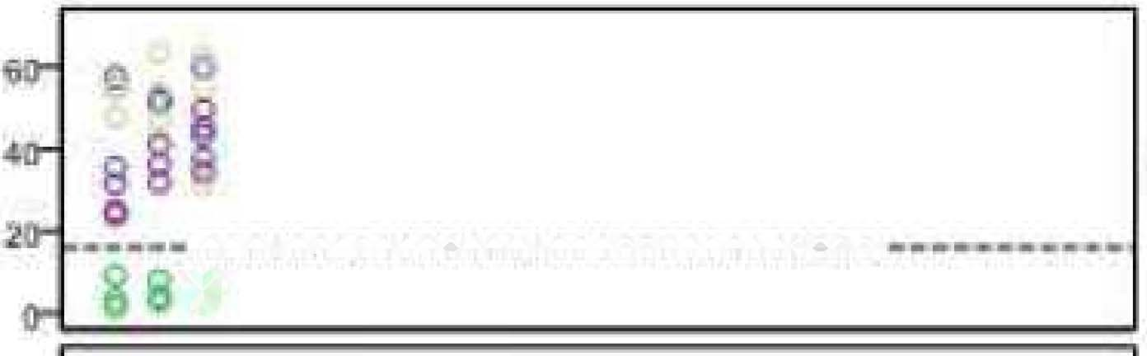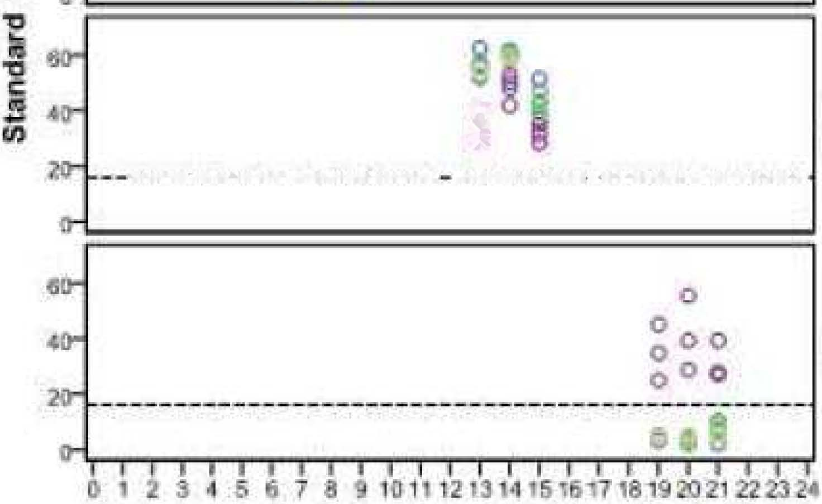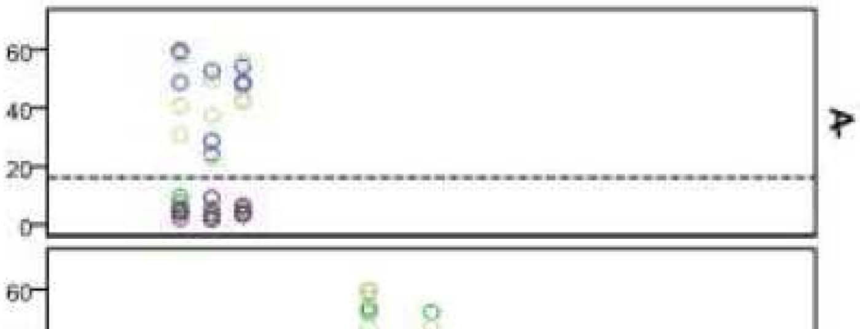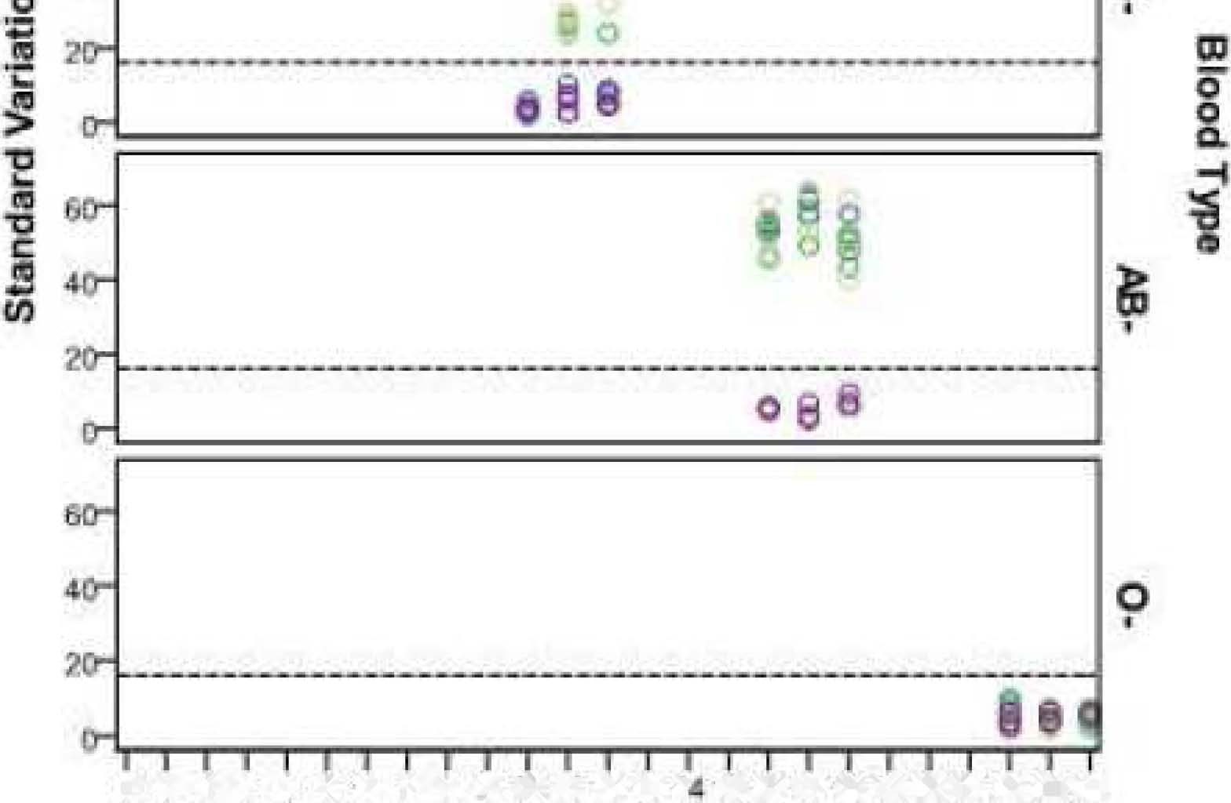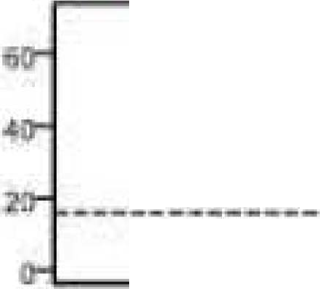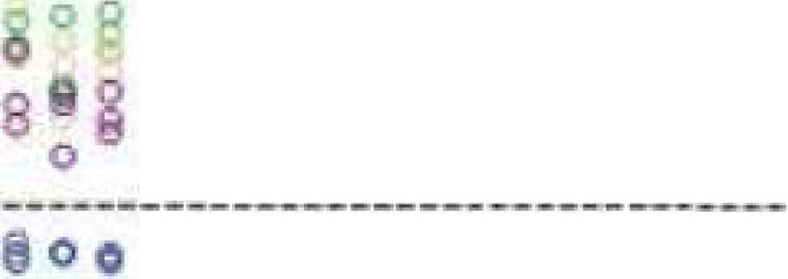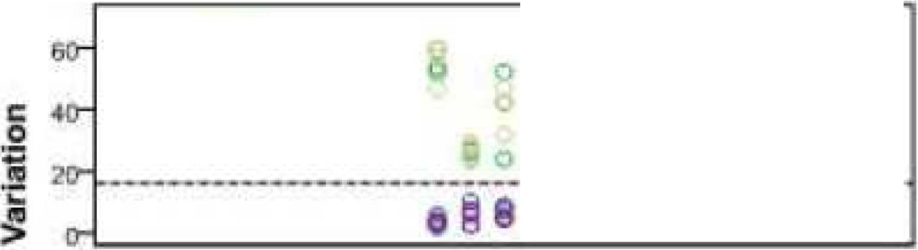

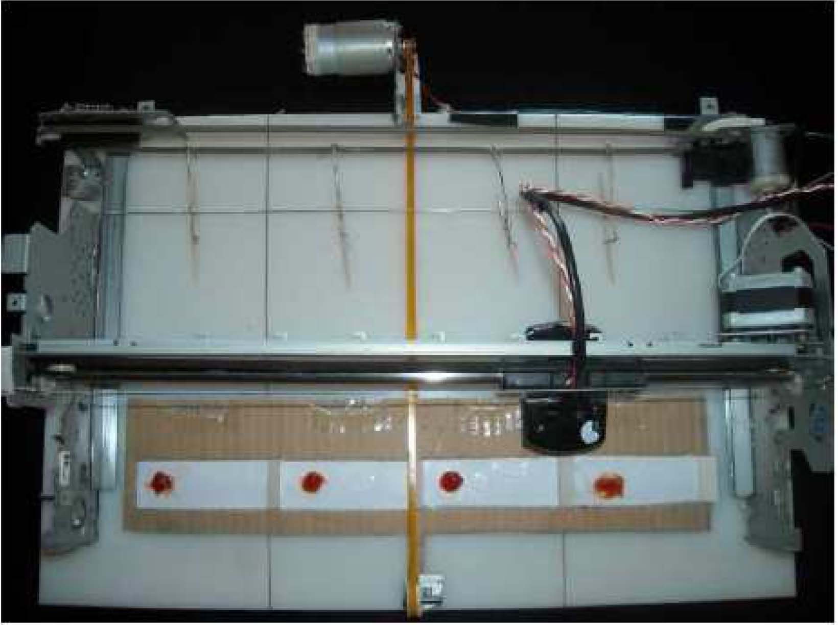Figure 11. System developed.

The system requires that the blood and the reagents are manually introduced, in slides, by the user. It is placed on the first slide the reagent anti-A, in second reagent anti-b, in third reagent anti-AB and in fourth slide the reagent anti-D. Thereafter, the system moves the slides for the mixing area, the blood and reagents are mixed. This mixture is performed with a DC motor and without contamination between the samples. Ended the mixing, slides are moved to the image capture area, where a motor drives the WebCam Glossy, 5 Mega pixels, along the sample, capturing an image of each slide. These images are stored for later analysis. The system is controlled by a microcontroller.

1. STATISTICAL ANALYSIS

This section presents the statistical analysis used to prove that the boundary between occurrence of agglutination and non occurrence is reliable. Namely, there are no values of agglutinated samples below the limit (16) and there are no values upper the limit (16) for samples that are not agglutinated.

This statistical analysis allows determining the reliability of the methodology used as well as the limit set on the basis of statistical tests. To this end, it was used blood of 24 patients and determining the blood type of each one, using the software developed and presented in this work. For each patient, the procedure for determining the blood type was repeated three times in order to verify whether the results were similar. There

j i

...--- .. .. ... .!_..._-.-- ... � i

o

+

SubJoct

Figure 12. Standard deviation values obtained by image processing techniques, for all patients Rh Positive (D Positive).

Serum

OAflr.A o Anb-B

AnD-A.B

D

0,2345818 9 'Olln'3" '5161118'9202'22Z32�

Subject

Figure 13. Standard deviation values obtained by the image processing techniques, for all patients Rh Negative (0 Negative).

The study of variability was performed, initially for individuals' Rh positive and at a second stage, for individuals Rh Negative. The dashed line represents the limit of standard deviation, 16, set out to determine the occurrence of agglutination, or non-occurrence. For all samples, there were

no standard deviation values that could lead to wrong decisions. For example, in case of blood type A+ (A Positive), agglutination was not observed for the reagent anti-B in all tests (Figure 13, green). For this case, all standard deviation

values obtained are below the threshold. For the case of blood type 0- (0 Negative), agglutination does not occur in all reagents and in all tests, all standard deviation values obtained are below 16 (Figure 14). On the other hand, for blood type

AB+ (AB Positive), all values are greater than 16 (Figure 13). For each test the agglutination was detected always getting standard deviation values greater than or equal to 16. The same was true for the absence of agglutination, obtaining values of standard deviation always below 16.

1. EXPERIMENTAL RESULTS

This section presents the experimental results of this work. Observing Figure 14 agglutination not occurred in samples a),

b) and c); and in sample d) there was agglutination. Through the standard deviation values of TABLE 3, this is also confirmed as samples a), b) and c) present values of standard deviation of 3.0, 2.3, and 2.4 respectively (all bellow 16), sample d) obtained 56.2 (above 16). Having verified the non occurrence of agglutination in anti-A, anti-B and anti-AB reagents, it is confirmed the absence of antigens AB in the blood sample analyzed. For the other hand, with anti-D reagent agglutination occurred so it is confirmed the presence of

antigens Rh in the blood sample analyzed. Thus, it can be concluded that the blood type in question is 0 Positive.

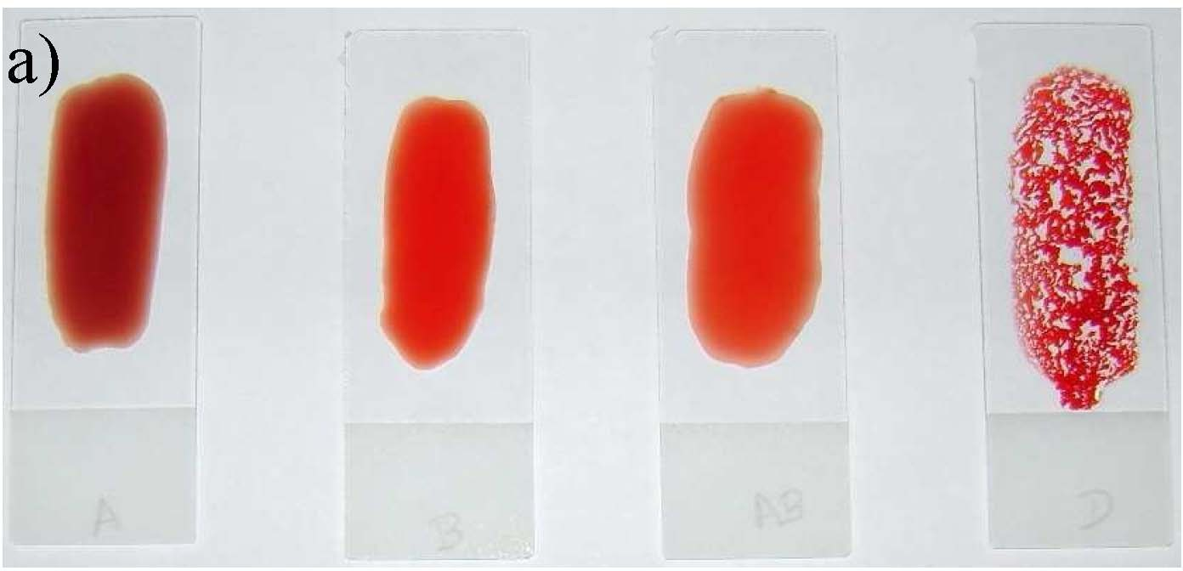

b)

c)

d)

Figure 14. Original image of 0 Positive (a) Reagent anti-A (b) Reagent anti-B

(c) Reagent anti-AB (d) Reagent anti-D.

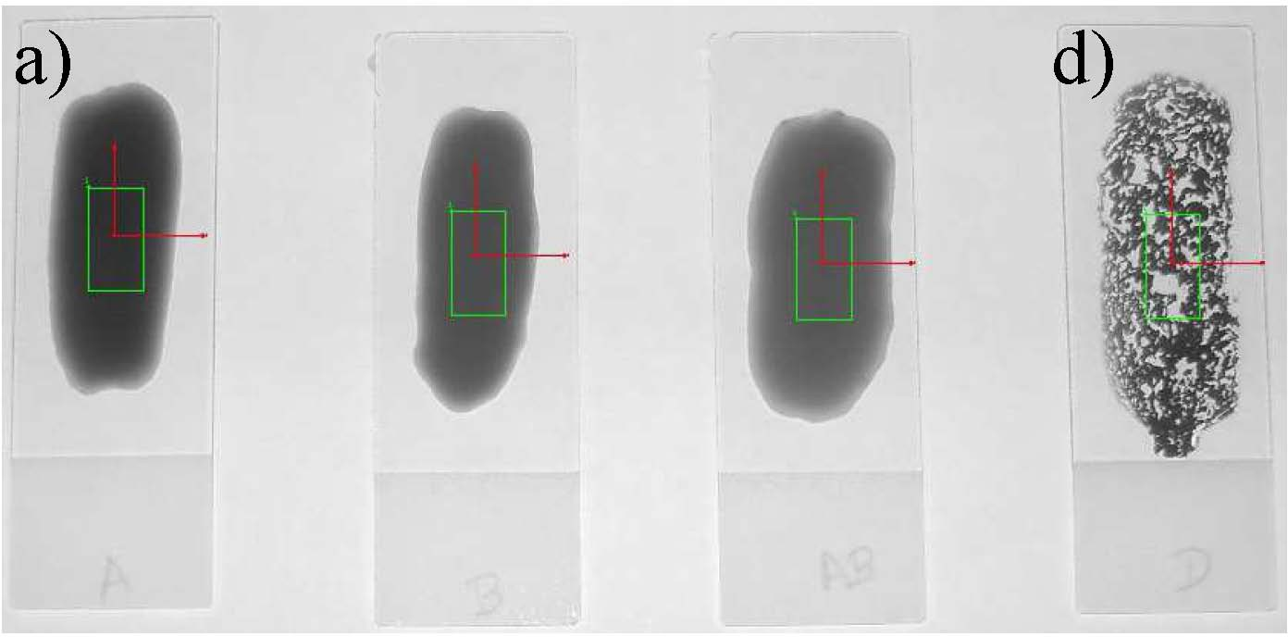

b)

c)

Figure 15. Image resulting from application of image processing techniques presented in Section II to the image of Figure 14.

TABLE 3. RESULTS OF ApPLICATION OF QUANTIFY FUNCTION ON IMAGE OF FIGURE 15



|  |  |  |  |  |  |
| --- | --- | --- | --- | --- | --- |
| 15(c) | 0,5 | 84,9 | 2,4 | 78,0 | 95,0 |
| 15(d) | 0,5 | 123,5 | 56,2 | 31,0 | 229,0 |

1. CONCLUSIONS

The methodology used in this work prove be effective and effIcient to detect the agglutination and determining the blood type of the patient. The use of image processing techniques enable automatically detect the occurrence of agglutination and determine the blood type of the patient in a short interval of time (about 5 minutes from the moment that the blood sample is collected until the output of results), adapting to emergency situations. The approximately 288 tests performed with different blood types, allowed validate the methodology used since had always the same expected results. The performance of these tests in addition to validate the methodology allowed certifies the validity of the threshold value established, standard deviation (sd=16) between samples agglutinated and non agglutinated. This methodology makes possible analysis for determining the blood type, in emergency situations, enabling the administration of compatible blood type on the first unit of blood transfusion, eliminating possible blood incompatibilities.

In future it is intended to improve the system developed by making it smaller so that it can be portable and incorporate GSM technology, to send a message to the mobile of technician of the laboratory in order to avoid unnecessary travel. In addition, it is intended to incorporate other pre transfusion tests required in the system so that the performing transfusion been more safely as possible.

ACKNOWLEDGEMENTS

The master thesis author are grateful to the supervisors Vitor Carvalho and Filomena Soares (Algoritmi Research Centre, Portugal).

DISCLOSURE

Part of information included in this paper has been previously published in: Sensors & Actuators: A Physical, Volume 172, Issue 1, December 2011; 10 Encontro Nacional de

Bioengenharia, 1-4 March, 2011; BIODEVICES 2011 International Joint Conference on Biomedical Engineering Systems and Technologies, 26-29th January, 2011; EUROSENSORS XXIV, 5  8th September 2010;

BIODEVICES 2010 International Conference on Biomedical Electronics and Devices 2010, 20 - 23th January 2010 and CBIS'2008 XI Congresso Brasileiro de Informatica em Saude, 29 November - 3 December 2008.

REFERENCES

[I] M. R. Brown, P. Crim. "Organizing the antibody identification process," Clin Lab Sci, vol. 20, 2007, pp. 122-126.

Figure Area

Mean Standard Minimal Maximal

Value Deviation Value Value

1. B. A. Myhre, D. McRuer. "Human error - a significant cause of transfusion mortality," Transfusion, vol. 40, Jul.

15(a) 0,5

15(b) 0,5

49,3

77,7

3,0

2,3

39,0

70,0

61,0

89,0

2000, pp. 879-885.

1. J. Petaja, S. Andersson, M. Syrjala. "A simple automatized audit system for following and managing practices of platelet and plasma transfusions in a neonatal

intensive care unit," Transfus Med, vol. 14, 2004, pp. 281-288.

1. M. Delamaire. "Automation of the immunohematology laboratory," TransfusClinBiol, vol. 12, 2005, pp. 163-

168.

1. E. A. Henneman, G. S. Avrunin, L. A. Clarke, L. J. Osterweil, C. Jr. Andrzejewski, K. Merrigan, R. Cobleigh,

K. Frederick, E. Katz-Bassett, P. L. Henneman. "Increasing patient safety and efficiency in transfusion therapy using formal process defmitions," Transfus Med Rev, vol. 21, 2007, pp. 49-57.

1. E. A. Wagar, L. Tamashiro, B. Yasin, L. Hilborne, D. A. Bruckner. "Patient safety in the clinical laboratory: a longitudinal analysis of specimen identification errors," Arch Pathol Lab Med, vol. 130, 2006, pp. 1662-1668.
2. C. L. Turner, A. C. Casbard, M. F. Murphy. "Barcode technology: its role in increasing the safety of blood transfusion," Transfusion, vol. 43, 2003, pp. 1200-1209.
3. J. L. Callum, H. S. Kaplan, L. L. Merkley, P. H. Pinkerton, B. R. Fastman, R. A. Romans, A. S. Coovadia,

M. D. Reis. "Reporting of near-miss events for transfusion medicine: improving transfusion safety," Transfusion, vol. 41, 2001, pp. 1204-1211.

1. M. M. Mueller, E. Seifried. "Blood transfusion in Europe: basic principles for initial and continuous training in transfusion medicine: an approach to an European harmonization," TransfusClinBiol, vol. 13, 2006, pp.

282-285.

[10]D. Stainsby, H. Jones, D. Asher, C. Atterbury, A. Boncinelli, L. Brant, C. E. Chapman, K. Davison, R. Gerrard, A. Gray, S. Knowles, E. M. Love, C. Milkins, D.

B. McClelland, D. R. Norfolk, K. Soldan, C. Taylor, J. Revill, L. M. Williamson, H. Cohen. for the SHOT Steering Group "Serious hazards of transfusion: a decade of hemovigilance in the UK" Transfus Med Rev, vol. 20, 2006, pp. 273-282.

[II]F. Ana, C. Vitor, S. Filomena and L. P. Celina, "Characterization of Blood Samples Using Image Processing Techniques", Sensors & Actuators: A. Physical(impact factor: l.674).

[12] "Blood Policy and technology", Congress, Office of Technology Assessment, Washington, DC: U.S. January 1985. Available: FAS [http://www.fas.orglota/reports/8505.pdf.](http://www.fas.orglota/reports/8505.pdf)

[13]P. Sturgeon, "Automation: its introduction to the field of blood group serology," Immunohematology Journal of Blood Group Serology and Education, vol. 17, no. 4, 2001.

[14]W. A. Coakly, "Handbook of Automated Analysis", Mercel Dekker, 1981 pp. 6l.

[15]G. W. Ewing, "Analytical Instrumentation Handbook," 2nd ed., Ed. New York: Marcel Dekker, pp.152.

[16][AutoAnalyzerhttp://weather.nmsu.edu/Teaching_Material](http://weather.nmsu.edu/Teaching_Material) Isoil698/Student_Material!AutoanalyzerlAutodiag.html (accessed in January 2013).

[17]M. Garretta, J. Gener, A. Muller, C. Matte, J. Moullec, "The Groupamatic System for Routine Immunohematology", Transfusion, vol. 15, Sep.-Oct. 1975, pp. 422-431.

[18]D. Zaccarelli, G. Monti, J. Malaguti, D. Marchesini, F. Figliola, G. Cagliari, C. basile, P. Zucchelli. "Esperienza di automazione nella determinazione dei gruppi sanguigni," La Transfusione del Sangue, vol. 45, no. 1, gennaio - febbraio 2000.

1. Olympus http://www.olympus- global.com/en/magazine/techzone/vol67_e/page5.cfm (accessed in January 2013).
2. Fuji <http://www.mastgrp.com/Fuji/IFU/TPPAauto.pdf> (accessed in January 2013).
3. Olympus, "Formulated for use in Automated System Olympus® PK® Systems", December 2007.
4. [Immucorhttp://immucor.comlsite/aum_company](http://immucor.comlsite/aum_company)�rofile.j sp(accessed in January 2013).

[23]G. Wittmann, J. Frank, W. Schram, M. Spannagl. (2007). "Automation and Data Processing with the Immucor Galileo® System in a University Blood Bank," Transfusion Medicine Hemotherapy. vol. 34, pp. 347-

352. Available: [Kargerwww.karger.com/tmh.](http://www.karger.com/tmh) [24]Briefi[ngresearchhttp://www.briefingresearch.com/General](http://www.briefingresearch.com/General)

Content/lnvestorlActivelArticlePopuplArticlePopup.aspx

?SiteName=lnvestorPopUp&Articleld=NS20070619155I 12AheadOfTheCurve(accessed in January 2013).

[25]Stanford

<http://securities.stanford.edull035/BLUD05_01/200622J> o1c_0502276.pdf(accessed in January 2013).

[26]A. Dada, D. Beck, G. Schmitz. (2007). "Automation and Data Processing in Blood Banking Using the Ortho AutoVue® Innova System". Transfusion Medicine Hemotherapy, vol. 34, pp. 341-346. Available: [Kargerwww.karger.com/tmh.](http://www.karger.com/tmh)

[27][Biologichttp://www.fda.gov/downloads/BiologicsBloodV](http://www.fda.gov/downloads/BiologicsBloodV) accines/BloodBloodProductslApprovedProducts/Licensed ProductsBLAs/BIoodDonorScreening/BIoodGroupingRea gent/ucm080763.pdf(accessed in January 2013).

[28]S. Y. Shin, K. C. Kwon, S. H. koo, J. W. Park, C. S. Ko,

J. H. Song, J. Y. Sung, "Evaluation of two automated instruments for pre-transfusion testing: AutoVueInnova and Techno TwinStation", Korean j Lab Med., vol. 3, Jun. 2008, pp. 214-220.

1. Datasheet of DiamedDiaclon Anti-A, Diaclon Anti-B, Diaclon Anti-AB. Cressiers/Morat, 2008.
2. IMAQ, "IMAQ Vision Concepts Manual", National Instruments, Austin, 2004.
3. T. Klinger, "Image Processing with LabVIEW and IMAQ Vision", Prentice Hall, New Jersey, 2003.

[32]C. G. Relf, "Image Acquisition and Processing with LabVIEW", CRC Boca Raton, 2003.

1. Datasheet of Diamed-ID Micro Typing System, Card-ID. Diaclon ABO\Rh for patients. Cressier, 2008.
2. SPSS 17.0, SPSS <http://www.spss.com/> (accessed in January 2013